BAFA’s Basics
  - For Secondary Schools (2)
  - 2016 – 2017

The Exmouth Community College American Football Programme

Secondary School (2): Competition Format

by [Article Author]
The standard format that is used for Youth American Football (under 18) in the UK is BAFA’s National Leagues’ 5v5 flag and full-contact football. The Youth Tournaments take place during the summer over a couple of months.

5v5-plus
The Secondary format for the School Games (and also for the Touchdown Football National School Championship) is different to the National League format. The extent to this difference is small but significant. In normal 5v5 flag and full-contact football there is no kicking. In the new 5v5-plus format there is a kick-off to establish field position and a 4th-down field goal attempt. For full the full rules, go to: Below are some key points about the new rules.

The kick-off.
Team A line up with the kicker. The ball is placed on a cone 3-4 yards from the sideline on the goal line. After signaling readiness to his or her team, the kicker runs and kicks the ball. Their team sprint after it. Team B attempt to make a clean catch and then run the ball past the half-way line. If they do this without being touched by two different Team A players, they start their drive on the 5-yard line. If they fail to get the ball past half-way, they start on their goal line.
However, Team A must kick a catchable ball. They also must not kick it so hard it goes through the back of the End Zone. If this happens, Team B are awarded 2 points. If the ball is kicked and goes out through the side-lines, Team A get 1 extra point.

4th-Down Field Goal attempt.
If the team with the ball gets to 4rd-down and they are a long way from the half-way line, they can elect to kick for a 2-point field goal. However, if they miss their attempt, the other team will be awarded an extra point. Behind the End Zone there will be a small area marked-out with cones to signify the scoring zone. The ball has to land within this area to count. BAFA rules can be found at; rules.bafra.org/rules/rulebook/bafa2016/index.htm

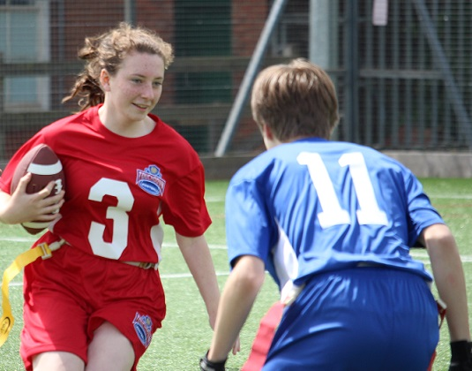
See also; BAFA’s Basics for See Video Resources in BAFA You-Tube
For more information, contact: schools@britishamericanfootball.org
