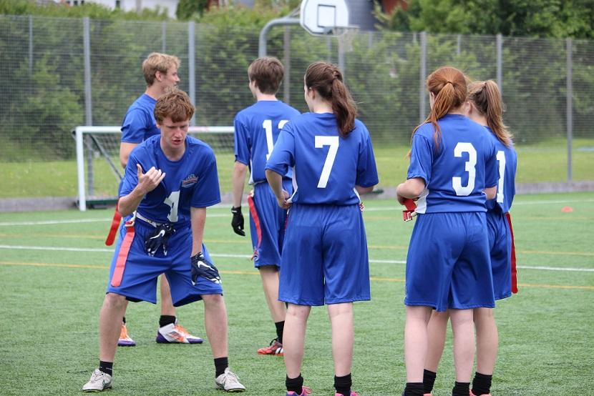 |  | BAFA’s Basics  - For Secondary Schools (1)  - 2016 – 2017

The Exmouth Community College American Football Programme

Secondary School (1): Challenge Cards

by [Article Author]
American Football can be best explained by saying it is a bit like a very complicated version of ‘piggy-in-the-middle’. A player throws the ball to a team-mate and the opposition tries to stop them. It is a type of game called an ‘invasion game’ where one team tries to get into the other team’s territory and score.

The Challenge Cards
The three Challenge Card activities are designed to develop the skills to play 3v3, 4v4 and 5v5+ American Flag Football. They are based on standard American Football drills and exercises but turned into fun games.
End Zone Excitement: This is practice for the scoring play either in the game situation or in the extra point situation or in a competition tie-breaker. A very intense activity involving speed, awareness and quick reactions! The team with the ball from the 5-yard line burst into the End Zone to attempt to catch the ball. The Defense must bat the ball away or catch the ball themselves.
Lightening Rugby: This is the same game as the 5v5 format but without the player who holds the ball for the Quarterback at the snap (called the ‘Centre’). The Quarterback holds the ball themselves. This makes the start of the play faster.
Ultimate Football: American Football’s version of ‘ultimate frisbee’. Popular amongst many teams as a great work-out and warm-up game. Teams pass the ball across an area of play and attempt to score touchdowns. If a team drops the ball, possession goes to the opposing team. Fast and a great deal of fun.

Additionally
All the Primary School Challenge Cards are equally appropriate for Secondary School students – TCR (Throw, Catch, Run), Defend the Box and the Field Goal Challenge all develop key American Football skills, so they are worth adding into the sessions with older students.
Exclusive kicking balls and the Kicking kit are only available form Youth Sport Direct.

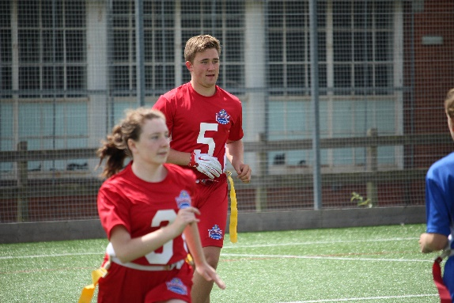
See also;
BAFA’s Basics for Students BAFA’s Basics for Inclusion
BAFA’s Basics for Secondary Schools (2)
For more information, contact: schools@britishamericanfootball.org

