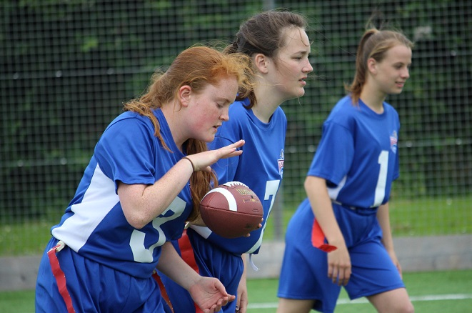 |  | BAFA’s Basics  - For Primary Schools (2)  - 2016 - 2017

The Exmouth Community College American Football Programme

Primary Schools (2): Terminology

by [Article Author]
The School Games Competition and Challenge Card activities have been developed to introduce youngsters to the fun of American Football. American Football can be best explained by saying it is a bit like a very complicated version of ‘piggy-in-the-middle’. A player throws the ball to a team-mate and the opposition tries to stop them.
Format and terminology
The Competition format for Primary Schools is 3v3. Normally American Football is 11v11 at adult level but there are other formats; 9v9, 8v8, 7v7, 5v5, 4v4 and 3v3. In all of these formats there are the same key positions;
The Quarterback – this is the player that starts the play.
Each play starts with a ‘snap’ where the Quarterback effectively says ‘ready, steady, go!
Throwing the ball is called a ‘passing play’.
Giving the ball by hand to a Receiver is called a ‘running play’.
The Receivers – the players that catch the ball.
The Defensive backs – these players mark the Receivers and try and intercept or disrupt the throw or tag the Receivers.
The Safety – this player watches the ball and attempts to tag which ever Receiver gets the ball.
3v3
This format means that the children will be very involved in the game all the time. With only two Receivers to throw to, all the children playing will get lots of opportunity to catch and run with the ball. It also means that more games can be played at the same time. This format is very easy for the children to understand and they will quickly be plotting all kinds of different plays! For 3v3 Rules see BAFA’s Basics of 3v3 Flag Football.

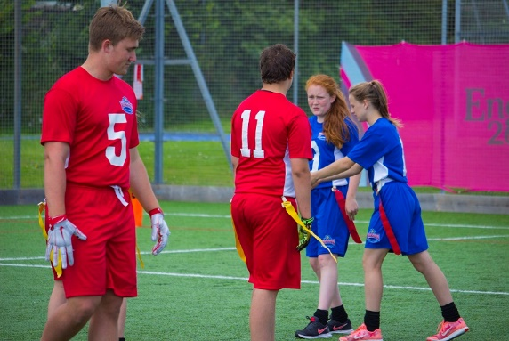
See also; http://www.youthsportdirect.org/ (for kicking kit) See Resource Video example; BAFA You-Tube
For more information, contact: schools@britishamericanfootball.org
