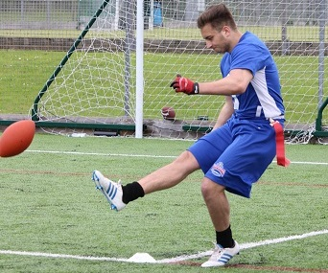 |  | BAFA’s Basics  - For Primary Schools (1)  - 2016 - 2017

The Exmouth Community College American Football Programme

Primary Schools: Challenge Cards

by [Article Author]
The School Games Competition and Challenge Card activities have been developed to introduce youngsters to the fun of American Football. American Football can be best explained by saying it is a bit like a very complicated version of ‘piggy-in-the-middle’. A player throws to ball to a team-mate and the opposition tries to stop them.
The Challenge Cards
The three activities on the Challenge Cards are designed to encourage team-work, competition and some new skills;
TCR – Throw, Catch and Run: A simple team game that is very exciting and a lot of fun. Teams line up and on a whistle the first player runs forward to pick-up a ball to throw back to the next person in line. At the same time that they are running back, the next person, having caught the ball, runs forward to then throw the ball back. Develops hand-eye co-ordination, sprint-running, catching skills and throwing skills and so on. Any ball can be used for this.
Defend the Box: A standard American Football drill turned into a great team game. Players take it in turn to stand in a box area. The opposition run through the box to the other side to score a touchdown. The defending player has to ‘tag’ the opposition using flag or tag belts. Develops hand-eye co-ordination, ability to tag, running in different directions and responding to change of direction and team spirit.
Field Goal Challenge: As in rugby, after a score teams kick for additional points. In American Football this has to be done under extreme pressure and with extreme accuracy. This activity just takes the set-up for a kick that involves walking backwards, walking side-ways, stepping back and then taking two quick steps to kick the ball into a target area (an American Football goal-shape laid out on the ground with cones). Teams get two kicks each to score points. A surprisingly popular activity for boys and especially for girls! Develops balance and kicking skills. Exclusive kicking balls can be bought from Youth Sport Direct.
Watch video demonstrations!

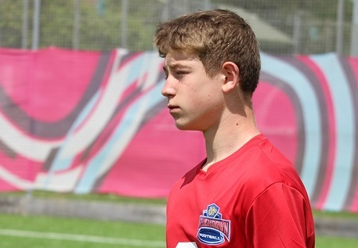
See also: http://www.yourschoolgames.com/sports/level-1-primary http://www.youthsportdirect.org/(for kicking kit) See Resource Video example:
BAFA You-tube
Contact: schools@britishamericanfootball.org
