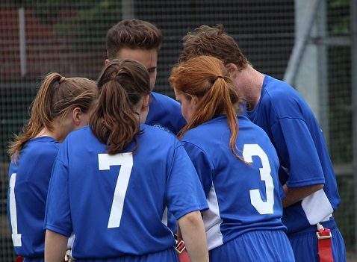 |  | BAFA’s Basics  - For Inclusion  - 2016 - 2017

The Exmouth Community College American Football Programme

Inclusion

by [Article Author]

How is it inclusive?
American football, away from the glare of the extreme version that is the NFL, is a sport full of surprises. The game itself is very different to other sports that British youngsters will have played. In particular, it is the ‘regimented’ nature of the play that is both different and the key to inclusion. Think one-pass-rugby, netball and chess and you have a concept of the game. In reality, it is not much more than ‘piggy-in-the-middle’ but the way American Football evolved from the best bits of rugby has created a really unique game.

Inclusion by sex and gender.
American Football is a truly co-ed sport. Even at NFL level: if you meet the requirements, you can play (or officiate or coach). As the photos on this page illustrate, males and females can play and compete as true sporting equals – a very rare situation in sport. Many of the UK BUCS University teams are co-ed.

Inclusion by SEN.
The sport is unique as unlike most UK sports it does not rely on that elusive (for many children) ‘intuitive’ understanding of the game. American Football is a game of pre-planned and rehearsed ‘set-pieces’. This can be delivered in a very achievable way. For example, a ‘3-and-in’ route can be delivered initially as ‘take 3 steps forward, turn in towards the middle of the pitch, look at the quarterback and get ready to catch the ball’. A player can simply learn this one route and practice it over and over again. The rise in confidence and self-esteem can been seen clearly s the student masters this simple route. The same is true for Officiating – two simple fouls can be watched for and penalties awarded (by throwing a yellow ‘flag’).

Inclusion by limited mobility.
Whilst in Flag Football there needs to be fast runners, there is also the position of Centre and Quarterback both of which suit those with limited and very limited mobility (wheelchair users, cerebral palsy and those with prosthetic limbs).

See also;

Inclusion article;
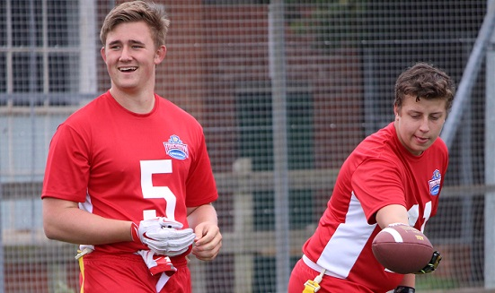
See more in ‘BAFA’s Basics for’ For more information, contact:
schools@britishamericanfootball.org youthsporttrust.org
