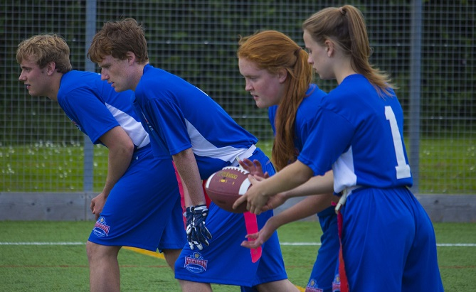 |  | BAFA’s Basics  - For clubs and coaches  - 2016 - 2017

The Exmouth Community College American Football Programme

For Clubs and Coaches

by [Article Author]
The opportunities that existing American Football clubs can gain from the School Games and the Touchdown Programme can only benefit a club and its members.

More engagement with schools
With the inclusion of American Football into the School Games and in the formats being presented will help the development of your own youth programme. Firstly, the unique competition formats will not under-mine or contradict anything you are currently offering. The new competition formats simply increase opportunities for a growth in participation. Secondly, School Games schools will want School Games activities which you can provide for them. Non-School Games schools can be offered the Touchdown Programme (BAFA’s Official School Programme) or your own delivery format and model.

Tried and tested
All the activities in the School Games are basic football drills and activities. They were thoroughly vetted by the YST to match the general standards that other NGB’s follow. Working with an NFL Development Officer and with BAFCA’s Director of Coach Education and Training, the activities were scrutinized from a specific football perspective, too. The activities were further tested at four trial events involving (in total) around 350 youngsters. Feedback was collected from organizers, teachers and the students themselves. Exclusive equipment to support these activities (for example new kicking balls) has been developed and is available from Youth Sport Direct.

‘School Games Friendly’ logo
To help the School Games Organizers, teachers and other people involved, Clubs can apply to gain the ‘School Games Friendly’ logo to put on their social media. This simply says that the Club understands the Challenge and Competition Cards and can help and advise. To learn more email: schools@britishamericanfootball.org Several clubs have already gained the logo and understand how these new initiatives can further develop their own youth programmes.

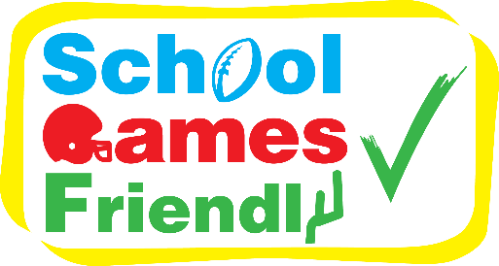
See also;
BAFA’s Basics for www.fsem.ac.uk/flipbook/concussion_guidelines/files/inc/8daa5501fb.pdf
schools@britishamericanfootball.org
