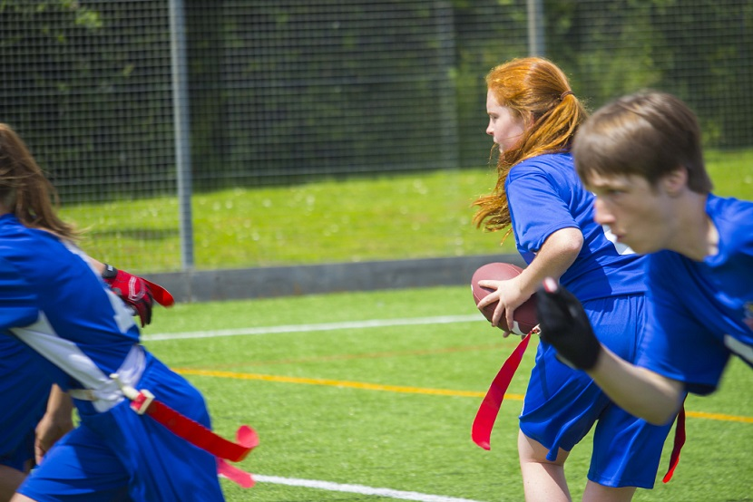 |  | BAFA’s Basics  - For SGOs  - 2016 - 2017

The Exmouth Community College American Football Programme

School Games Organizers

ers

by [Article Author]

What is American Football?
American Football can be best explained by saying it is a bit like a very complicated version of ‘piggy-in-the-middle’. A player throws to ball to a team-mate and the opposition tries to stop them. What makes American Football different to most UK sports is that it is based on set-plays rather than players ‘making-up plays on their own’. Football is a very ‘intuitive game’, something many children struggle with. American Football, on the other hand, is a combination of one-pass-rugby, netball and chess!

I don’t know enough about it?

BAFA offers a number of ways that it can support the SGOs. Key is the network of Touchdown Activators and Advisers. To contact your local TDAA contact:

britishamericanfootball.org

There are also the BAFA registered clubs that will be more than willing to help out – look for the ones with the ‘School Games Friendly’ logo opposite at the top.

This means that they can advise specifically on the school games competitions and challenge cards.

Is it expensive?

No, all schools will already have the basics: tag-belts and cones. The only equipment that they might want to buy will be a ball: the official BAFA supplier is;

http://www.footballamerica.co.uk/shop/

The exclusive school games products can be found on;

http://www.youthsportdirect.org/

in particular the Kicking Kits and Officiating Kits.

The Inclusion Kit can be ordered direct from;

http://www.wottonprinters.co.uk/

along with the three Leadership Awards.

For more information on the Touchdown Junior Flag Activator Certificate, contact;

schools@britishamericanfootball.org

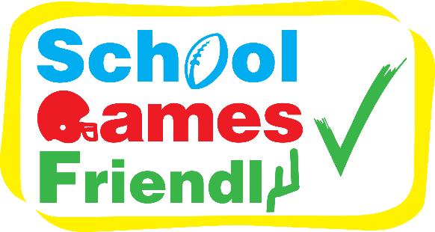
See also;
BAFA’s Basics for Teachers BAFA’s Basics for Students BAFA’s Basics for Inclusion
For more information contact: schools@britishamericanfootball.org
