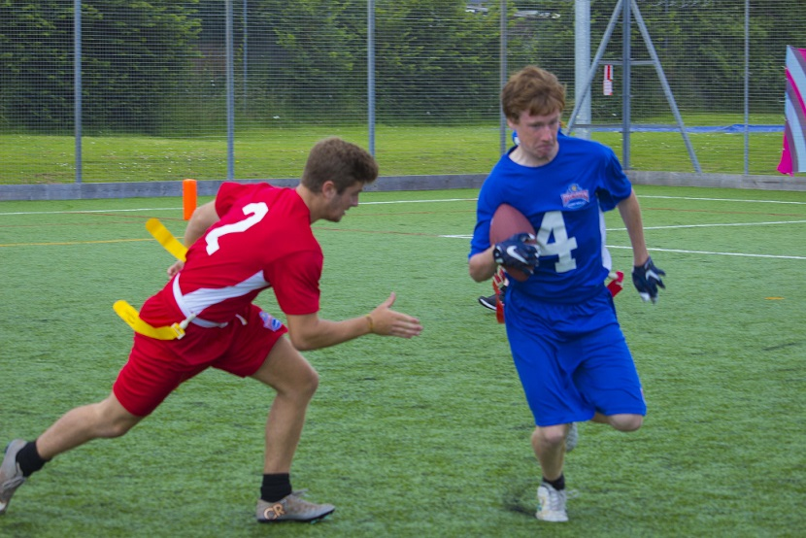 |  | BAFA’s Basics  - For Students (1)  - 2016 - 2017

The Exmouth Community College American Football Programme

Students (1)

by [Article Author]

When can I play full-contact?
NFL American Football is the extreme adult version of the game. The players are above Olympic standard athletes and have spent most of their lives making a very difficult sport look really easy! It is also a collision sport (as opposed to rugby that is a tackling sport). Don’t be in a hurry to try full-contact (or ‘kitted’ football), there is plenty of time to make that progression. Learn the game and its techniques first!

But you have all that padding!
The term ‘padding’ is very misleading. It is better to think about it as ‘body armor’. It is also hard with edges, which means that it can hurt just tackling someone, if you don’t use the right technique. The ‘padding’ allows a player to strike another player with greater force than in rugby, so there is an increased risk of injury. The protection it offers is really only to do with the shoulder joints and collar-bone. Since you lead with the head in a tackle and you may hit your head against the pads, you wear a helmet.

But flag is not the same game!
Incorrect, unlike rugby and tag rugby there is only one game of American Football but it has a couple of different formats. Generally speaking, most young American Footballers in the UK play Flag Football. It is the same as NFL Football but with fewer players and no contact. So, the best way to learn full-contact football is to start with Flag Football. You will learn all the techniques and skill required, you will learn the rules and get lots of valuable game experience – all without the worry of getting injured. Once you feel you really understand the game, then you can make the choice of trying the full-contact version and concentrate on learning the correct tackling technique.

Is it a sport for girls?
Definitely! The sport is genuinely ‘co-ed’ meaning it is open for males and females to play on and against mixed teams. That is actually true of the NFL too! Since often boys and girls have no greater knowledge or experience than each other, makes the sport really fair!

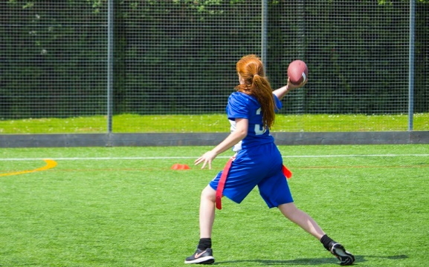
See also;
BAFA’s Basics for Inclusion NFLUK.com / NFL.com britishamericanfootball.org
youthsporttrust.org

