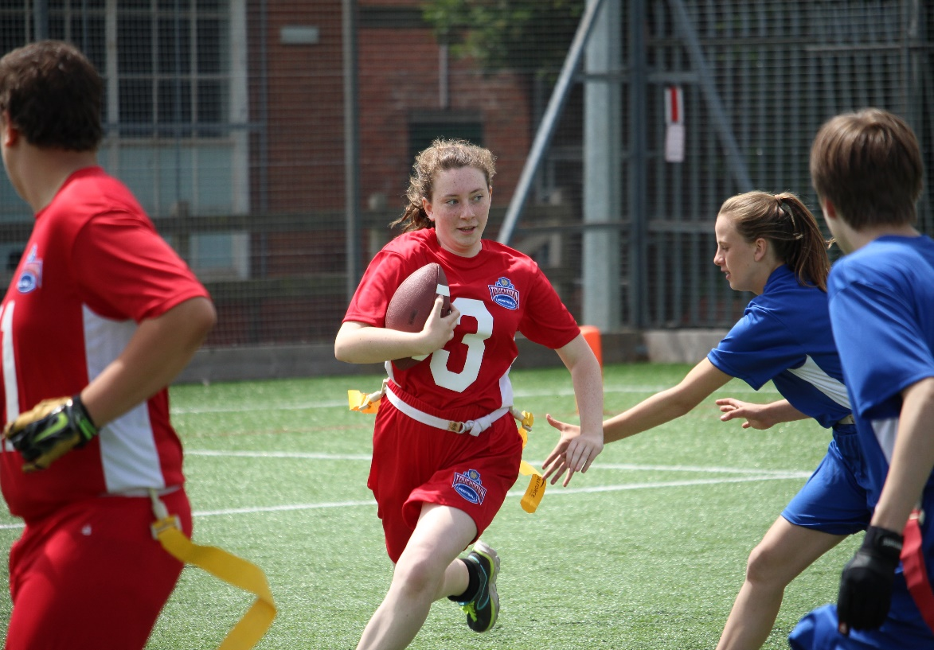 |  | BAFA’s Basics  - For teachers and schools  - 2016 - 2017

The Exmouth Community College American Football Programme

Teachers and Schools

by [Article Author]

What is American Football?
American Football is an and very different invasion game. It is fully inclusive and highly adaptable to different athletic levels. Based more on the principles of chess – that pieces can only move in a regulated way - players in American Football do not need an ‘intuitive understanding’ of the game to play it at a high level of skill. It is a game of ‘set-pieces’ that in the NFL are rehearsed until perfected (and NFL players have to learn around 230 set-pieces). It can be best explained by saying it is a bit like a very complicated version of ‘piggy-in-the-middle’. A player throws the ball to a team-mate and the opposition tries to stop them.

We don’t have the equipment!
One of the really great things about American Football is that your students can play a non-contact version that is the same as the NFL. Although it has fewer players (the formats for the School Games are 3v3, 4v4 and 5v5), it still delivers the skills you need for the full-contact version. The rules are pretty much the same too! It is also better that they learn the game safely – the local American Football Club will be the best place for them to try the full-contact version. For yourself, this is a great addition to your PE lessons and it offers something completely different in a team invasion game (think one-pass rugby, netball and chess!).

We don’t have the knowledge!
British American Football can offer a great deal of support and resources. Look at the BAFA’s Basic for Resources and Help – you may be surprised at the support that can be offered to you and even exclusive School Games products that you can buy (see youthsportdirect.org).

How inclusive is the game?
American football is a sport full of surprises and in more ways than one. It is fully inclusive for those with limited mobility and also for SEN youngsters. For example, players run set routes – ‘3-and-in’ can literally mean ‘run 3 paces and turn in to catch the ball’. Therefore, this

makes the sport highly accessible to a wide variety of student. With simple routes being learnt and repeated, confidence and skill levels increase rapidly. Routes are also adaptable for the slowest and fastest runners.

Look at the article on the Youth Sport Trust website;

There are Video Resource examples on BAFA’s ‘You-Tube’

fsem.ac.uk/flipbook/concussion_guidelines/files/inc/8daa5501fb.pdf

For more information, contact;

schools@britishamericanfootball.org

