BAFA’s Basics
  - of National Schools’ Championship
  - 2016 - 2017

The only official BAFA Schools’ Programme

The National Schools’ Championship

by [Article Author]
The National Schools’ Championship is open to any school registered under the Touchdown Football Programme and including any School Games Schools. Unlike BAFA National League Competitions, the new Touchdown National Schools’ Championship is comprised of three individual elements: a 5v5-plus Flag Tournament, a Kicking Competition and a Quarterback Competition. The school that accumulates the most points from the three elements to gain an overall score will be crowned the National Schools’ Champion.

5v5-plus
The format for the Touchdown Football National School Championship is different to the National League format. The extent of this difference is small but significant. In normal 5v5 flag and full-contact football there is no kicking. In the new 5v5-plus format there is a kick-off to establish field position and a 4th-down field goal attempt. See BAFA’s Basics of 5v5-plus Flag Football.

The Kicking Competition
As with such competitions that are staged in America, the Kicking competition will involve a series of kicking tasks to test both form and accuracy of the kicker. Full details will be made available in due course.

The Quarterback Competition
As with the Kicking Competitions in America, several kicks and kicking challenges will be offered with the opportunity to score points for the overall team score. Full details will be made available in due course.

International Opportunities
BAFA is currently working with the NCSS (National Council for School Sport) to have American Flag Football entered into the ISF (International School Sport Federation) as a demonstration sport. If this is successfully run for three years, the sport becomes a full ISF sport. Eligible schools will come from the finalists and runners-up of the Touchdown National Schools’ Championship games.

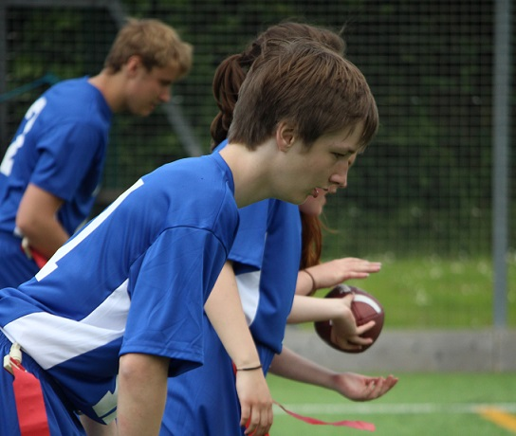
See also; http://www.ncss.org.uk/index.htm http://www.youthsportdirect.org/
For more information, contact: schools@britishamericanfootball.org Resource Videos can be found at; BAFA You-Tube
