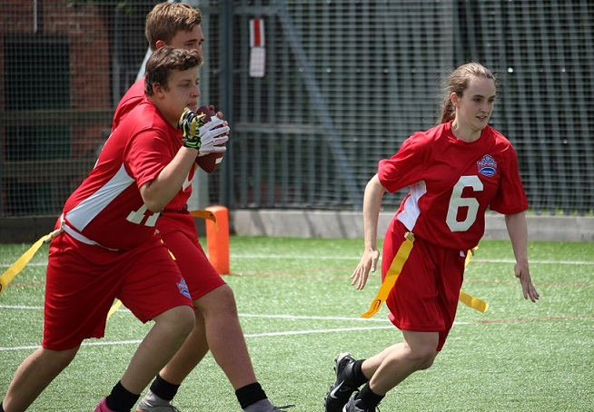 |  | BAFA’s Basics  - of 3v3 Flag Football  - 2016 - 2017

The Exmouth Community College American Football Programme

3v3 Flag Football

by [Article Author]
The 3v3 Flag Football is a fast and more inclusive format than 5v5 Flag. The game allows for more opportunities for players to participate and get fully involved. It also means that more games can be played in a PE lesson and the task of students officiating the games is easier for them with less action to watch (one person officiating 5v5 is quite difficult).

The Rules of 3v3
Essentially, 3v3 Flag is played with the same rules as 5v5 Flag. For a full copy of the BAFA 5v5 Rules go to;
http://rules.bafra.org/rules/flag/index.htm
Player positions are: Quarterback and two Receivers on Offense and Safety and two Defensive Backs on defense. However, to make the game more enjoyable and to create a development of the students’ skills and understanding of the game, the following changes in the rules have been made.
A suggested field dimension suitable for Yr5 & 6 is: 10-yards across and 15-20-yards long, with a 5-yard end zone at each end Given a smaller area of play, teams only have 4 attempts (downs) to move the ball across the entire field and score. However, to encourage moving the ball forward in a controlled manner, teams cannot score on the first two downs and cannot score until the ball is moved past half-way. If a player is lucky enough to break free from the defensive players marking them and they get past half-way on first or second down, they should judge what would be a good distance to score from in the next down and therefore ‘step-out’ at that point (trying to score from very close to the goal-line is difficult). This is a rudimentary skill that applies in 5v5 and in the full-game (re: being tagged in the no-run zone in flag and time-management – stepping out to stop the game clock). There is no ‘blitzing’ of the QB (as this is quite intimidating for the younger player and can easily knock confidence). If the ball touches the ground the play is dead. The defending team can take possession of the ball if it is cleanly intercepted or if the catch is muffed by the Receiver and the live ball is caught by the Defending player in mid-air.

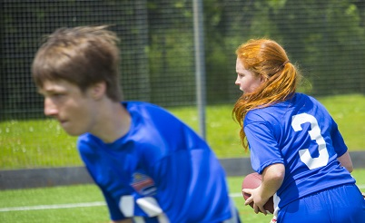
See also;
BAFA’s Basics for Students BAFA’s Basics for Primary Schools (1) & (2) BAFA’s Basics for Inclusion
For more information, contact: schools@britishamericanfootball.org
Resource Video examples can be found at;
BAFA You-Tube

