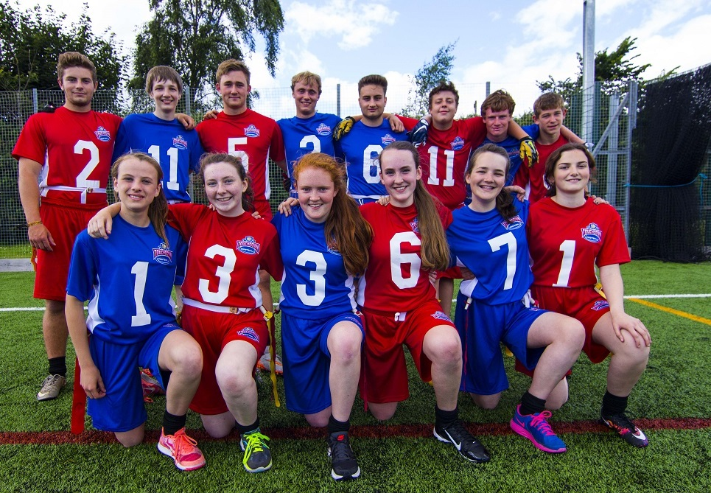 |  | BAFA’s Basics  - For Parents  - 2016 - 2017

The Exmouth Community College American Football Programme

Parents and Carers

by [Article Author]

What is American Flag Football?
American Football can be best explained by saying it is a bit like a very complicated version of ‘piggy-in-the-middle’. A player throws to ball to a team-mate and the opposition tries to stop them. It is a type of game called an ‘invasion game’ where one team tries to get into the other team’s territory and score.
The version of American Football that your son or daughter will be playing is called ‘Flag Football’ and is in some ways like Tag Rugby. Instead of physically tackling a player, the player running with the ball is tackled by having a flag (or tag) pulled off their belt. However, unlike Tag Rugby, Flag football is the same game as the NFL version but with fewer players and no contact! When you watch American Football, you are watching two coaches trying to out-do each other (because the coaches tell the players what predetermined and pre-rehearsed plays they want the team to run). The team simply have to learn what they have to do in each play – NFL teams have Playbooks of around 230 plays! In Flag teams don’t really need to learn any more than 10 plays.

Is it safe?
All sports carry a risk of injury and even Flag Football carries a certain element of risk of a pulled-muscle or an accidental collision but the version to be played in schools will be strictly non-contact, thereby minimizing the risk as far as is possible.

Is it expensive?
No, one of the great things about Flag Football is that schools already have all the equipment needed. Often they will just need to buy a ball! There is a type of ball called a ‘pass-back’ that makes for a great present. It has a flat end so that when it is thrown against a wall, it bounces back to the person – great for practicing on your own!

Are there local clubs?
Yes, look on the BAFA website – britishamericanfootball.org - club finder.

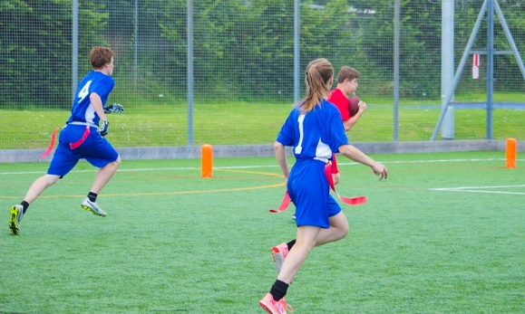
See also;

BAFA’s Basics for Students BAFA’s Basics for Inclusion https://www.youthsporttrust.org/
For more information, contact:
schools@britishamericanfootball.org

