British American Football Association:  Touchdown Football and the Sainsbury’s School Games |  | BAFA’s Basics  - ‘for’ and ‘of’ Explained  - 2016 - 2017

BAFA’s Basics ‘for’ and ‘of’ explained

by [Article Author]
British American Football Association is proud to promote American Football in schools through the Touchdown Football Programme and the Sainsbury’s School Games. To allow the maximum amount of participation in this great sport, BAFA has produced a number of brief information sheets aimed at specific partners promoting the non-contact version of the game called ‘Flag Football’.

‘BAFA’s Basics for’
The ‘BAFA’s Basics for’ series are short introductory magazine-style pages that provide simple explanations of a range of American Football topics including photos and links too other BAFA’s Basics for pages, links to further resources and useful contact details. They are not meant to be an exhaustive review of that topic but a quick guide with pointers about where you should go next.
Each ‘BAFA’s Basics for’ is aimed at a discrete partners providing specific information for example;
BAFA’s Basics for Parents
BAFA’s Basics for Students
BAFA’s Basics for Teachers
etc.

‘BAFA’s Basics of’
To compliment the ‘BAFA’s Basic for’ information sheets, there is also the ‘BAFA’s Basic of’ series, in the same style as the ‘BAFA’s Basics for’ but content-wise, the ‘BAFA’s Basics of’ relate to the more technical questions that people may have for example;
BAFA’s Basics of 3v3 flag football
BAFA’s Basics of 5v5 flag football
BAFA’s Basics of the National Schools’ Championships.

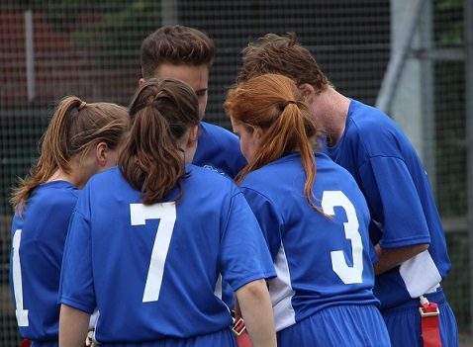
See also;
https://www.youthsporttrust.org/ http://www.youthsportdirect.org/ http://www.britishamericanfootball.org/
For more information, contact: schools@britishamericanfootball.org

